 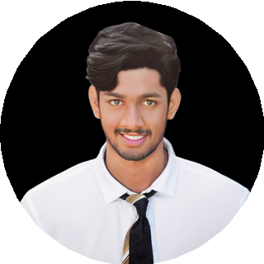

**T USHA RAHUL BELAMMKONDA**

**S T U D E N T**

|  |  |
| --- | --- |
| 630-4747-097  [tushrahul82@gmail.com](mailto:tushrahul82@gmail.com)  yadla palli vari street., Narsapur  reallygreatsite.com | **P R O F I L E**  I'm Tusha Rahul Bellamkonda, and I'm a third-year BTech student studying machine learning and artificial intelligence. I embrace a curious and practical approach to learning, having grown up in the vibrant town of Narsapur. My goal is to land a significant position in a developing business, where I can use my abilities and be challenged to provide committed service to the firm. |
| **S K I L L S** | **E X P E R I E N C E**  **ACADEMIC WORKS**  Indian Servers  Duration - 3 Months  Internship On Machine Learning. Developed a Drug Description Chatbot.  Takes name of the drug and give the effects and side effects.  **WEB APPLICATION DEVELOPER**  College Project  1 month  Streamlit web application  A Web Appliction which translates Documents to other languages. Acted as a team leader for a team of 6 members of distinct dedication  **EXTRACURRICULAR ACTIVITIES**  Sport and Clubs  Member of c Coding club. Member of college Arts Club.  Acted as a team leader for a team of 6 members of distinct  dedication. |
| Web Design |
| Design Thinking |
| C, Python and Java Programming |
| Front End Coding |
| Computer Skills |
| AI Tool Development |
| Chatbot Development |
| Strong Communication |
| **E D U C A T I O N** |
| **10 TH AND + 2** |
| Flaiz Memorial higher Secondary School Of S.D.A, Narsapur |
| 2019 - 2021 |
| **B. TECH- ARTIFICIAL INTELLIGENCE & MACHINE LERANING** |
| Swarnandhra College Of Engineering and Technology, Sitarampuram |
| 2021 - 2025 |